Analysing the Impact of COVID19 on Retail Businesses in the United Kingdom: A data Science approach from 2019 onwards.
Trevor Mukuve
Student number: 2414222
T.M.Mukuve@wlv.ac.uk
Table of contents
Abstract:
Introduction:
Literature review:
Results:
Discussion:
Conclusion:
References:
- literature review
Appendices:

Abstract
By harnessing data science techniques and leveraging comprehensive datasets, this study provides a nuanced examination of how the COVID19 pandemic has reshaped the retail industry in the United Kingdom, paving the way for informed strategic planning and decision-making. Through using open-source, reliable datasets, this study has aimed to compare and contrast the effectiveness of data science and different machine learning(ML) models in predicting the aftermath of consumer behaviour with respect to the Covid pandemic of 2019 onwards. This study has examined various methodologies, strengths, and weaknesses of different approaches by using Uk as a representative data point within multiple regions of this world. Considering the inherent limitations of drawing conclusions from a small dataset, it is important to practice alertness when interpreting our findings. However, our analysis indicates that
Introduction
Covid 19, a disease caused by a novel strain of coronavirus, was declared a global pandemic by the World Health Organisation on 11th March 2020 (World Health Organisation, 2024). The impact of Covid-19 in the Uk can be evidenced by the fact that the government took the extraordinary measure of imposing a nationwide lockdown to combat the spread of the virus in late March according to Hannah et al. (2024). This historic and unprecedented action saw the closure of all “non-essential” retail stores, including clothing and electronic stores, to ease pressure on the health service and to control the virus. However, supermarkets, pharmacies and others providing essential services were allowed to remain open so that there will be no shortages or panic buying of the products. This endorses the critical role that the retail industry in general, and supermarkets in particular, could play in times of crisis. In spite of the challenges faced by the retail industry during the pandemic, I have observed that several prominent retailers continued to invest in and adopt advanced technologies in order to satisfy the growing demands of consumers, particularly in terms of digitalisation and improved shopping experiences. An example of this is the online marketplace ebay, which experienced an increase in demand, witnessing greater website traffic and visitor numbers during the initial phase of the pandemic. Ebay’s report showed that customers purchased and sold more items, such as electronics, fashion and health and beauty products, in comparison to the same period in the year 2019. Ebay introduced various support packages and initiatives directed at facilitating the selling process for both new and existing businesses on its platform to combat the numerous changes in operations during this time. These initiatives involved waving registration and final value fess, offering an accelerator program to assist businesses in their growth. (Savitz,Eric, 2020). After providing some background, this report aims to understand the impact of COVID-19 on retail in the United Kingdom by identifying changes in customer behaviour and online shopping trends; to explore how different industry sectors have been affected and whether COVID-19 has led to a drastic shift in adoption of e-commerce in certain sectors; to use different data science techniques for example data preprocessing, machine learning and statistical modelling, to provide a detailed study in understanding the e-commerce market during the time of COVID 19; and to produce a predictive model that can help businesses and policy makers understand how different elements can contribute to the change in the e-commerce yearly or monthly sales.
Background & Literature review.
The literature review was very broad and vast with lots of contradicting information about there about the impact of Covid 19, some implying Covid had a negative impact on retail(eccomerce) business while others implying the opposite. Also, there’s little research done on the effects of Covid on the UK solely alone, instead most research has been done in another country with a slight comparison of ecommerce and covid data to the UK mentioned.
The following research paper focused on a more recent Job named ‘drop shipper’, which is a non-traditional mediator job between a manufacture and a consumer through means of IT and with the pandemic there was decrease in the volume of containers transported from China to the US from 37,311 TEUs to 4855 TEUs. (Dejan and Bono,2022). This shows an example of the severe negative impact that was cause by the Covid to global supply chains and markets especially on the online ecommerce market. In addition, this same paper highlights that the pandemic severely hindered trade development, particularly evident in the significant decline in online orders in the UK’ accessories category following the government’s COVID 19 containment measures announced after March 29. 2020. In this paper Uk ecommerce and Covid data is slightly used. Ritanjali et al. (2020, p.6) states that a lockdown for a long time would impact the economy of any country negatively as it shown by the negative growth of GDP especially in India.
Another paper showed that online sales of agriculture products increased immediately after the onset of COVID19, with the surge intensifying over time. The increase in sales was tremendous, peaking in the fourth- and sixth-months post-outbreak (114% and 122% increase, respectively), suggesting that COVID 19 accelerated the adoption of e-commerce for food and agricultural products. (Guo et al., 2022).
In addition, another research has shown a notable consequence that is the widespread adoption of e-commerce, even among non – traditional users for instance In Portugal, internet access and online buying increased in 2020, with a notable growth in the B2C e-commerce market. Similarly, in Spain, internet usage is prevalent across age groups, with a significant increase in online activity observed. (Higueras-Castillo, Liébana-Cabanillas and Villarejo-Ramos, 2023).
From my literature it is evident that there is abundant research data on ecommerce, retail and covid data and a lot of papers dealing with the same topic I have chosen. However, not enough analysis has been done solely on the UK.
Methodology:
The aim of this report is to analyze and predict the impact of Covid-19 on the ecommerce sector in the UK, relying on ethical and high-quality data, I primarily sourced the data from the Office for National Statistics (ONS), ONS provided three different data sources which provided both instore and online transactions as real-time indicators. I chose to use the Revolut data source for my report.
This report initially explores the broader impact of Covid-19 on retail businesses, with a specific focus on the advancement of technology within traditional retail sectors, particularly in-person and online transactions. I downloaded the data from the ONS website as a xlxs file on my laptop. I then deleted all the unnecessary information and just left the date as the independent variable and in-person and online shopping as the dependent variables.
The analysis was then conducted using Jupyter Notebook in Python, beginning with the importation of the panda’s library.
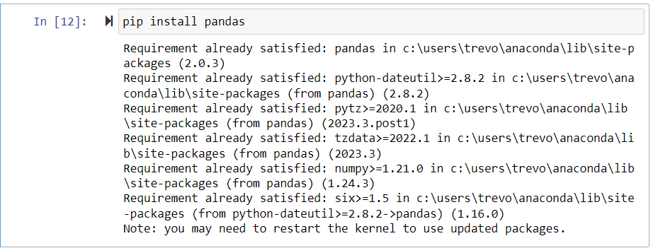
Then imported standard data science libraries for managing and visualising large datasets.

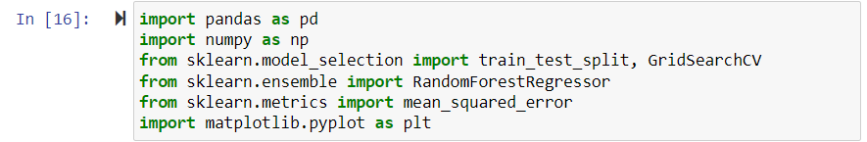

The next step involved me going to the ONS website (How our spending has changed since the end of coronavirus (COVID-19) restrictions - Office for National Statistics, 2022) where I downloaded the data locally to my laptop and manually added it to my code as follows;

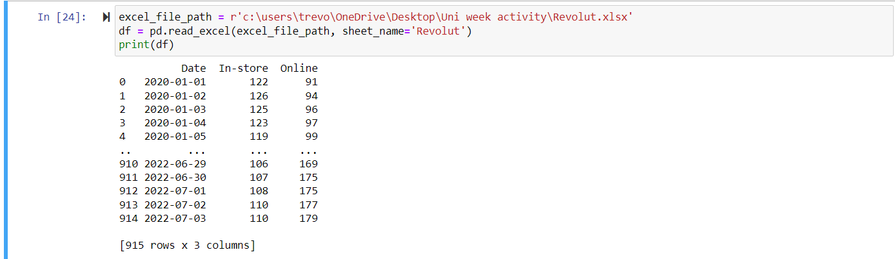

The screenshot below shows all the data and its randomness with the functions; df.head() which shows the first five 5 rows and the df.(tail) which shows the last 5 rows.
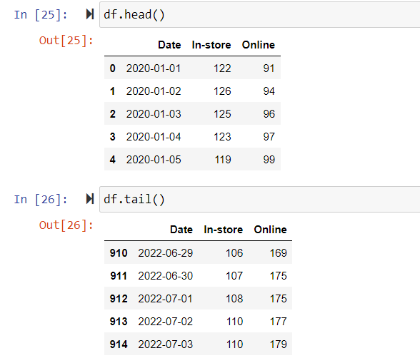

We the made a code that converts the ‘Date’ column in the Data frame ‘df’ to a datetime format.
Following up I coded extra additional features to help in further analysing pattern based on the day, month and year. I mainly focused on the year. ‘df['Year'] = df.index.year’ was used to add a new column ‘Year’ to the DataFrame. This can be helpful for identifying trends on a yearly basis.
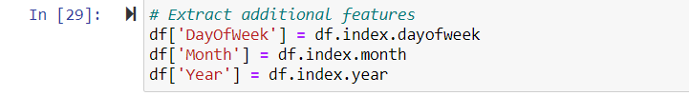
We incorporated machine learning where the code was used to split the DataFrame(‘df’) into training and testing sets. ‘train_size = int(len(df) * 0.8)’, was used to calculate the size of the training set. It takes 80% of the total length of the Dataframe(‘df’) and converts it to an integer. Then ‘train_data, test_data = df[:train_size], df[train_size:]’ was used performs the split which creates two new DataFrames ‘train_data and test_data’.
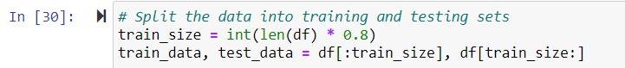

I added in features like ‘DayofWeek’, ‘Month’, ‘Year’ , ‘Online’ and ‘In-store’ to train the model and to help make predictions. The third line of code was used to set up a subplot for each target variable and the number of subplots is determined by the length of ‘target_variables’.
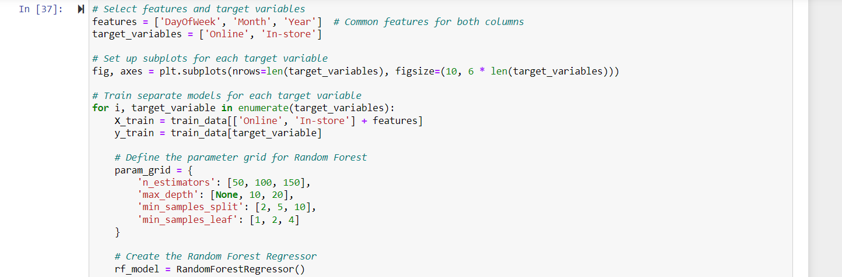
To set up the subplots this code was used and number of subplots is determined by the length of ‘target_variables’.

To train the model loop, this one was used to help the loop iterate over each target variable (‘Online’ and ‘In-store’) and inside the loop, the random Forest model is evaluated and trained for each target variable.
The next line creates a RandomForestRegressor, which is a machine learning model suitable for regression tasks.
The next line of code helps with Hyperparameter Tuning with GridDearchCV
The next 3 code lines were used to help print (first code) the best hyperparameters found during the hyper parameter tuning process. And the (third code) was used to help model evaluation and plots specifically to calculate and print the Mean Squared Error for each target variable.

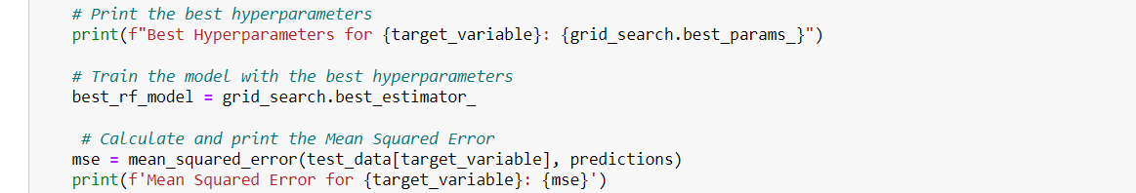
The next one was used to help plot the actual vs predicted values for each target variable on seperate subplots.
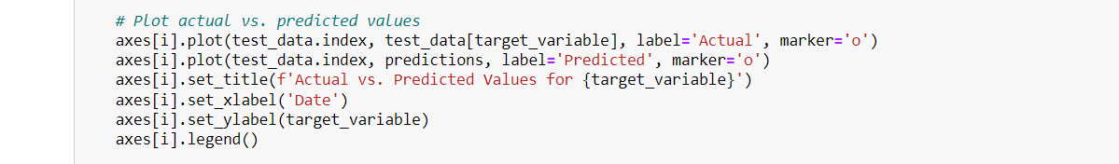
The next help to adjust the layout and display of the plots.


The next sections shows the output (Results of the predicted vs actual) graph for online shopping.
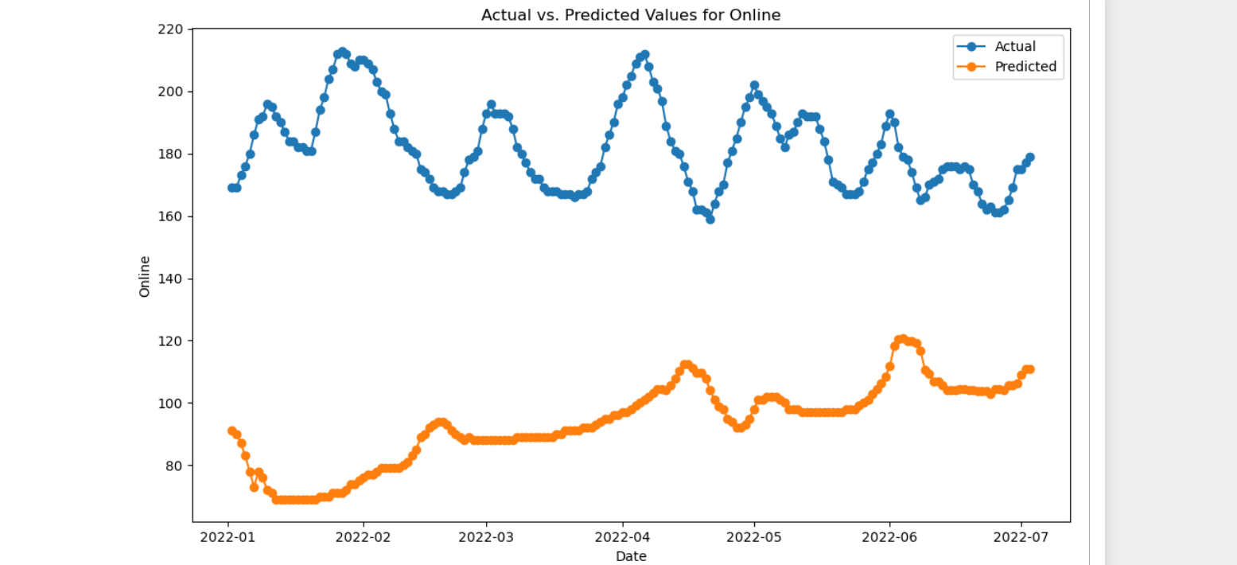
Additionally, there was some limitations to this report such as it’s only a 3000-word limit which means I am limited from testing even bigger data as I would require extra modelling and analysis. The analysis was solely focused on the Revolut data in the Uk, rather than multiple countries or regions hence it’s a small sample size which makes my analysis less reliable.
Results
For my results the trends and data are clear about the correlation between e-commerce and the Covid-19 from 2020 to 2022 in the UK. There is a clear correlation from personal observations and reading numerous literature that shows that ecommerce spiked a lot in during the COVID era especially in 2020 where instore purchasing was closed hence the public resorted to online purchase and ecommerce.
The graph below shows clear evidence of correlation between instore and Online purchase it shows that as the first locked down (The impact of COVID-19 lockdowns on crime demand and charge volumes in England and Wales, 2024). From 23/03/2020 the first lockdown you can see clearly that instore purchases decreased, and online ecommerce increased alongside in a similar trend. Reasons being people were told to stay indoors and social distance hence they reverted to online purchasing.
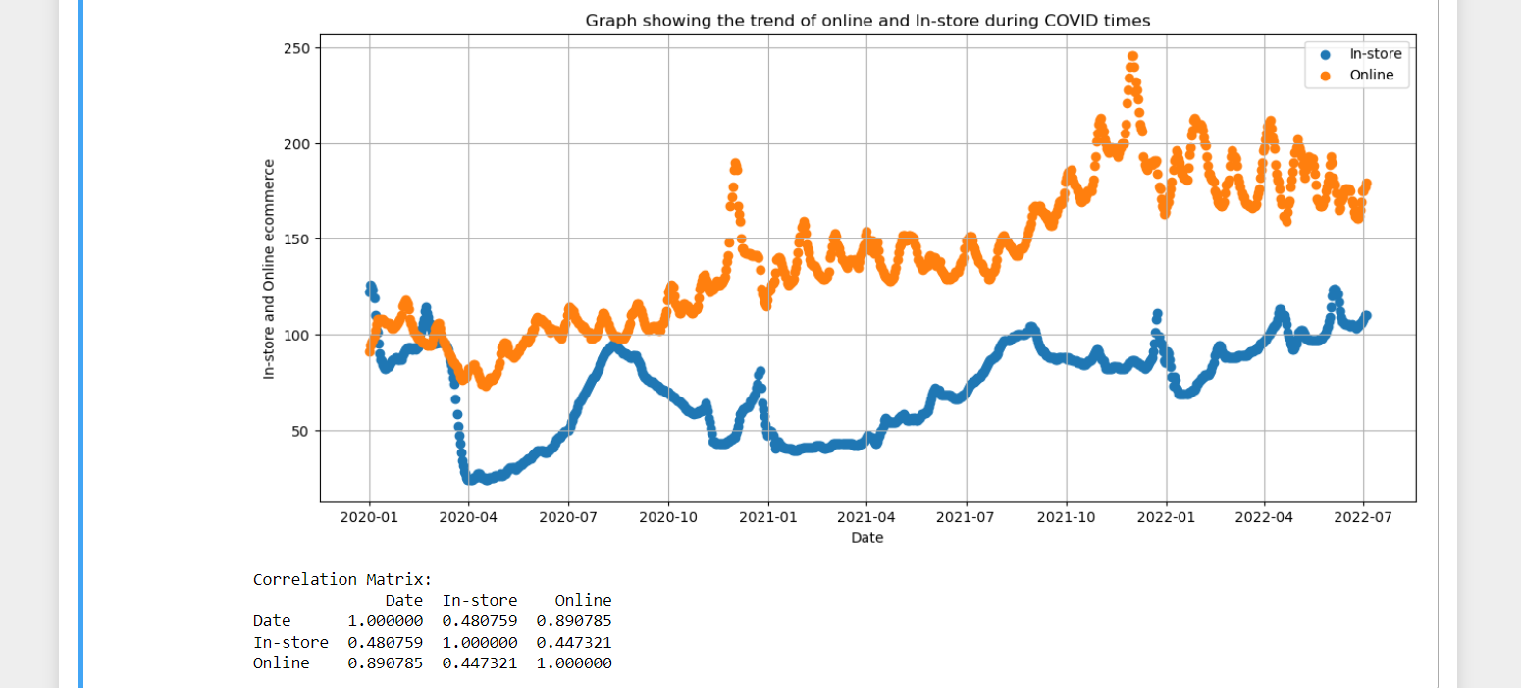
The next graph shows a very accurate prediction, with the predicted value being very similar to the actual value of the Online sales throughout this graph.
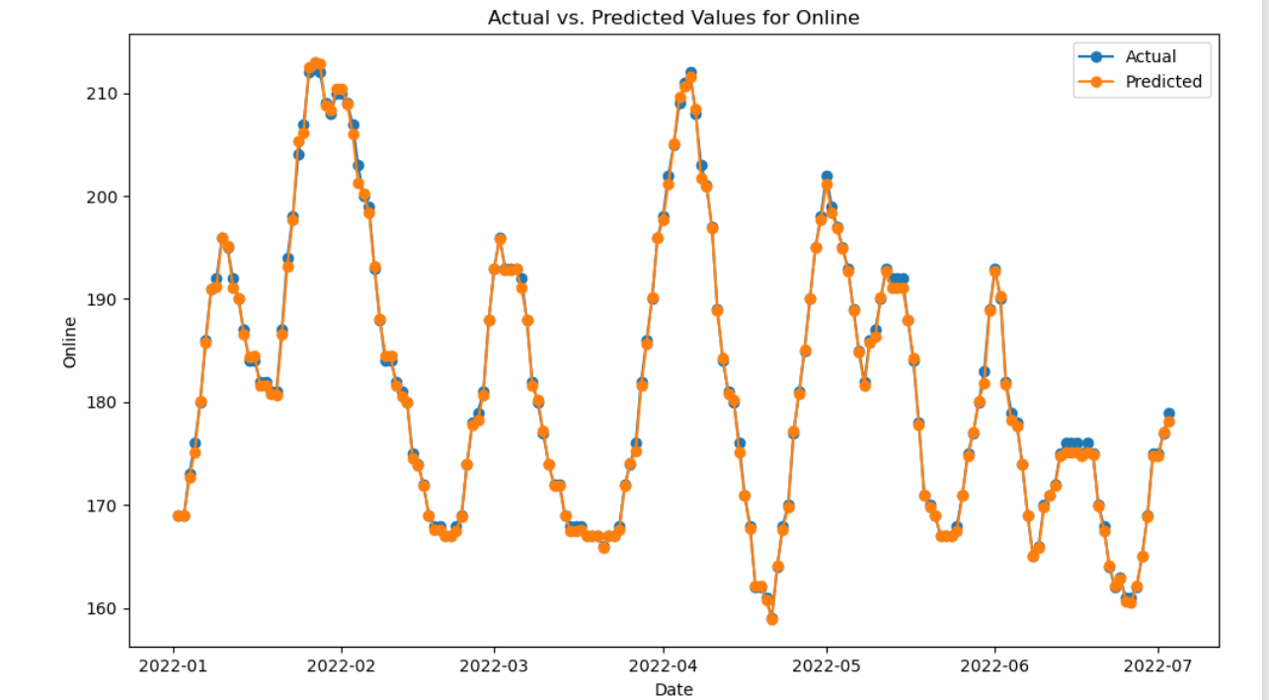

The next graph also shows a very accurate prediction, with the predicted value being very similar to the actual value of the In-store sales through this graph.

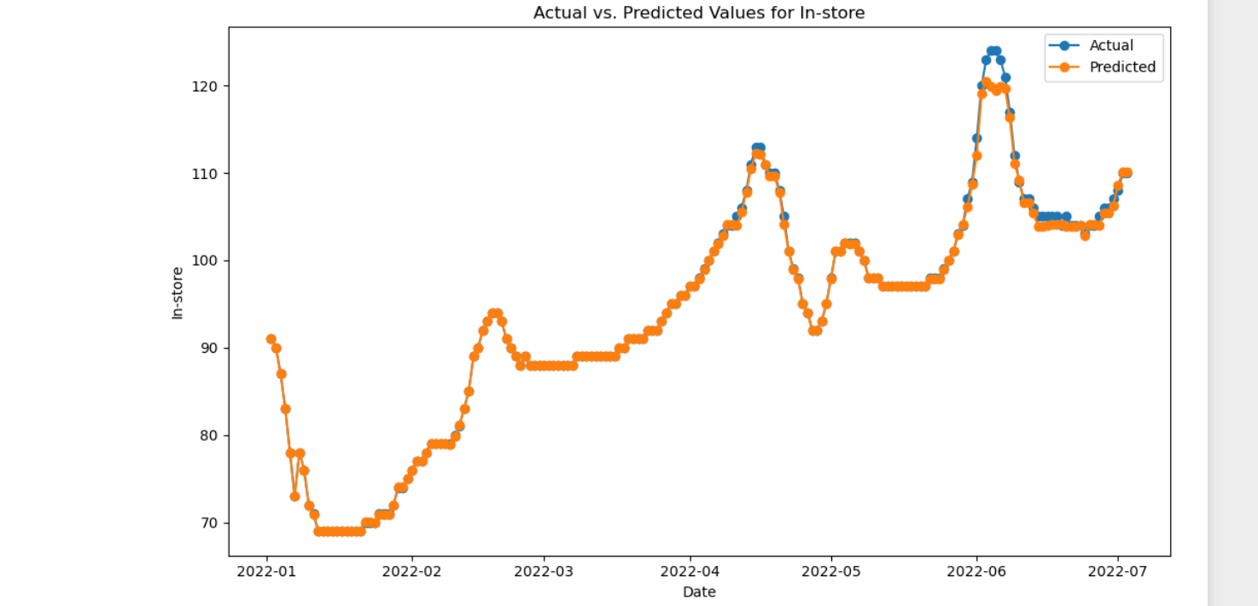
Discussion (925:
Effects on Ecommerce
The results appear to me as I expected. Firstly, with a close relationship and correlation between the predicted values and actual values for in-store shopping, as well as correlation to the times the UK government imposed the national lockdown and the covid cases. From the graph below there is clear correlation between the national lockdown and covid cases and people’s expenditure results. With the first national lockdown starting on the 23/03/2020 you can see from the graph instore purchasing reached it’s lowest in the covid era the following month of 4th/2020 on the graph up until some lockdown’s restrictions started getting lifted and instore purchase went back up. Whereas online purchases around this same time remained up and steadily increased. This really is a first sign to show a positive correlation of projection of people towards online ecommerce over traditional instore purchasing.
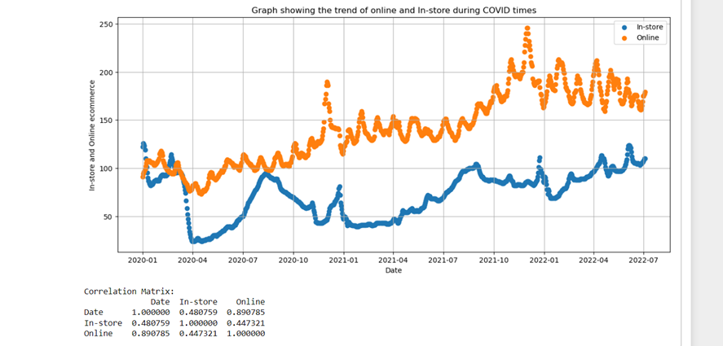
In addition, there is more examples of this correlation for instance; Interestingly between 2020/07 and 2020/10 most of the restrictions were lifted during this period and you can see that instore purchasing spiked back up rapidly to the point the blue dotted line touched with the orange dotted line showing that the Covid 19 cases and the national lockdown directly impacted instore purchasing as the lockdowns were lifted people went back to their normal traditional instore purchasing. However, a second lockdown was imposed on the 05/11/2020, you can see the effect on expenditure habits the following months, instore purchases went down gradually and in fact according to this graph from that time onwards the following years show overall that online expenditure being people’s first choice over traditional expenditure as the orange dotted line is always slightly higher the blue dotted line. Data is from (How our spending has changed since the end of coronavirus (COVID-19) restrictions - Office for National Statistics, 2022). Another paper from 2021 I researched showed that the number of digital buyers worldwide exceeds 2 billion and forecasted global e-commerce B2C sales are to reach $4.5 trillion by 2021. (Dumanska et al., 2021).

Conclusion
There is a observed shift towards online ecommerce, it shows the importance of having a strong online presence and robust digital infrastructure to compliment the change in consumer preferences. Businesses that fail to meet this change risk being left behind in this increasing digital market. Hence, they should invest in ecommerce capabilities, increasing online platforms for easy shopping experience and leveraging digital marketing strategies are crucial for remaining competitive. The analysis suggests a shift towards online commerce could persist even after the pandemic subsides. This is consistent with broader trends indicating a gradual transition towards digital commerce in recent years (get some papers)
As consumers get more used to the convenience and ease of access pf online shopping, traditional retailers may face continued challenges in attracting foot traffic and maintaining profitability. Furthermore, the pandemic has accelerated the use of digital payment methods and contactless transactions, confirming further the trend towards digital commerce.
With the forecasted growth in not only UK but also global commerce sales, as shown in my analysis, highlights the many opportunities available through the digital marketplace. Businesses that are able to capitalise on this trend are highly likely to benefit from access to a broader customer base and increased market share. However, it is important to note that that the shift towards online commerce is not the same across all industries and regions (get some papers). Business must gear their strategies to meet the unique needs and preferences of their target markets.
In summary, the results of my analysis provide valuable insights into the transformative impact of the COVID-19 pandemic on consumer behavior and the retail landscape. By understanding these trends and their implications, businesses can better position themselves to navigate the evolving digital marketplace and thrive in the post-pandemic era.

References
Savitz, E.J. (2020) ‘EBay Earnings Beat Expectations. The Pandemic Moved More Shoppers Online.’, Barron’s (Online), 28 July. Available at: https://www.proquest.com/docview/2427595124/citation/1D069DEA0D4D46C3PQ/1 (Accessed: 5 March 2024).
Worldometer(2024) Countries where COVID-19 has spread. Available at: https://www.worldometers.info/coronavirus/countries-where-coronavirus-has-spread/ (Accessed 5th March 2024)
World Health Organisation (2023) Coronavirus disease (COVID-19) pandemic. Available at: https://www.who.int/europe/emergencies/situations/covid-19 (Accessed: 5th March 2023)
Dumanska, I. et al. (2021) ‘E-commerce and M-commerce as Global Trends of International Trade Caused by the Covid-19 Pandemic’, WSEAS TRANSACTIONS ON ENVIRONMENT AND DEVELOPMENT, 17, pp. 386–397. Available at: https://doi.org/10.37394/232015.2021.17.38.
Guo, J. et al. (2022) ‘Has COVID-19 accelerated the E-commerce of agricultural products? Evidence from sales data of E-stores in China’, Food Policy, 112, p. 102377. Available at: https://doi.org/10.1016/j.foodpol.2022.102377.
Higueras-Castillo, E., Liébana-Cabanillas, F.J. and Villarejo-Ramos, Á.F. (2023) ‘Intention to use e-commerce vs physical shopping. Difference between consumers in the post-COVID era’, Journal of Business Research, 157, p. 113622. Available at: https://doi.org/10.1016/j.jbusres.2022.113622.
How our spending has changed since the end of coronavirus (COVID-19) restrictions - Office for National Statistics (2022). Available at: https://www.ons.gov.uk/businessindustryandtrade/retailindustry/articles/howourspendinghaschangedsincetheendofcoronaviruscovid19restrictions/2022-07-11 (Accessed: 12 March 2024).
The impact of COVID-19 lockdowns on crime demand and charge volumes in England and Wales (2024) GOV.UK. Available at: https://www.gov.uk/government/publications/the-impact-of-covid-19-lockdowns-on-crime-demand-and-charge-volumes/the-impact-of-covid-19-lockdowns-on-crime-demand-and-charge-volumes-in-england-and-wales (Accessed: 5 March 2024).
Miljenović, D. and Beriša, B. (2022) ‘Pandemics trends in E-commerce: drop shipping entrepreneurship during COVID-19 pandemic’, Pomorstvo, 36(1), pp. 31–43. Available at: https://doi.org/10.31217/p.36.1.4.
The impact of COVID-19 lockdowns on crime demand and charge volumes in England and Wales (2024) GOV.UK. Available at: https://www.gov.uk/government/publications/the-impact-of-covid-19-lockdowns-on-crime-demand-and-charge-volumes/the-impact-of-covid-19-lockdowns-on-crime-demand-and-charge-volumes-in-england-and-wales (Accessed: 5 March 2024).
UK: online revenue trend in fashion sector during COVID-19 2020 (no date) Statista. Available at: https://www.statista.com/statistics/1111036/fashion-weekly-online-revenue-growth-in-the-uk/ (Accessed: 6 March 2024).
Literature review:
Ketipov, R. et al. (2023) ‘Predicting User Behavior in e-Commerce Using Machine Learning’, Cybernetics and Information Technologies, 23(3), pp. 89–101.
Jain, P. and Sahu, S. (2022) ‘Prediction and forecasting of worldwide corona virus (COVID-19) outbreak using time series and machine learning’, Concurrency and Computation: Practice and Experience, 34(26), p. e7286. Available at: https://doi.org/10.1002/cpe.7286.

